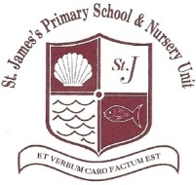

SAFEGUARDING and CHILD PROTECTION

If you have concerns regarding Safeguarding or Child Protection, the procedure to follow is outlined below.

Designated Teacher for Child Protection: Mrs Clenaghan
Deputy Designated Teachers: Mrs Farrell (Primary) and Miss Cullen (Nursery)

If I am still concerned, I can talk to the
Designated Teacher for Child Protection –
Mrs Brenda Clenaghan

I have a concern about my/a child’s safety

I can talk to the class teacher

If I am still concerned, I can talk/write to the
Chairperson of the Board of Governors –
Mrs Anne McDermott or the Designated Governor for Child Protection – Mrs Samantha Sayers c/o St James’s Primary School

(Mrs Kyra Pauley)

If I am still concerned, I can contact the
PSNI Public Protection Unit at 02890 650222
or a Social Worker from the Gateway Team at
0300 1234 333 or 028 9442 4459

